The Dragons’ Den tackles desertification in Burkina Faso

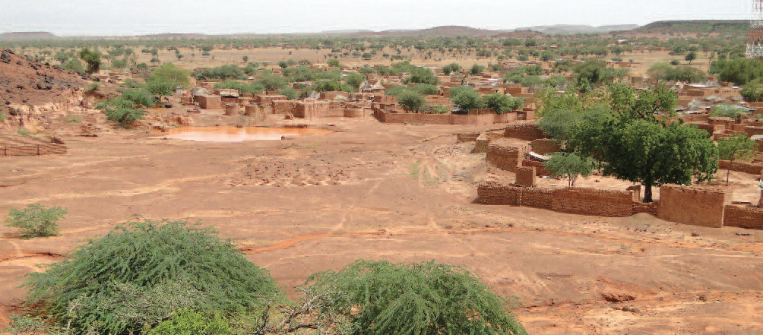

Homewear task :
All the groups in your class have pitched their projects to your teacher, now it is up to you to decide which project is best and which you will support and try to pitch to the real Geography Dragons.
Your decision should be based on two criteria:
• the project which will help to stop desertification, and
• the project which will help local people to improve their lives.

If appropriate, you can choose two projects which complement each other.
Once you have made your decision, you must be prepared to clearly justify your décision.
You have a choice of how you pitch your chosen project – written speech, or audio recording with or without images.
You also have a choice of whether you want to enter the Year 8 competition and pitch your projects to the Real Geography Dragons (Paul, Charlotte & Louisa) at lunch

Mark Scheme:

Grade | Criteria
D | Brief description of the project and how it will help stop desertification and also how it will help to improve peoples lives. Some justification provided of why it is the best projects but will lack detail.
C | Description of the project (s) and how it / they will help stop desertification and also how it will help to improve peoples lives. Generally good justification provided of why it or they are the best projects but may lack detail.
B | Detailed description of the project (s) and how it / they will help stop desertification and also how it will help to improve peoples lives. If two projects are chosen there should be a clear explanation of how they are linked and how they compliment each other. Generally good justification provided of why it or they are the best projects.
A | Detailed description of the project (s) and how it / they will help stop desertification and also how it will help to improve peoples lives. If two projects are chosen there should be a clear explanation of how they are linked and how they compliment each other. If voice recorded – real enthusiasm for the project expressed in the voice. Good justification provided of why it or they are the best projects.
A* | Detailed description of the project (s) and how it / they will help stop desertification and also how it will help to improve peoples lives. If two projects are chosen there should be a clear explanation of how they are linked and how they compliment each other. If voice recorded – real enthusiasm for the project expressed in the voice. Some evidence of independent research. Excellent justification provided of why it or they are the best projects.

