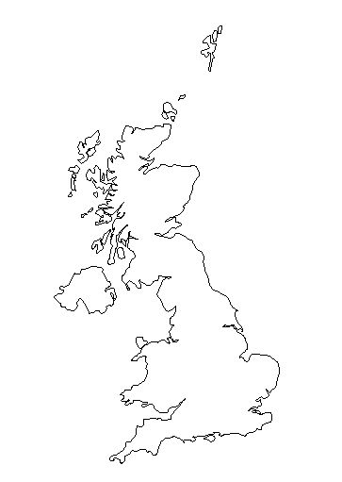**Sketch map of Spurn Head**

Locate Spurn Head on the map.

Key:

Remember to add both physical features ( sand, salt marsh…) and human features ( lighthouse)

Scale:

Don’t forget to colour it!

Place your sketch map in this box

N