**River Dijle – Fieldwork Study**

1. Annotate the photo to explain the possible problems.

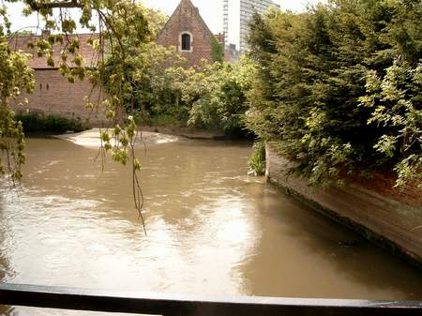

1. Annotate the satellite photograph of the flood management scheme to explain how it works

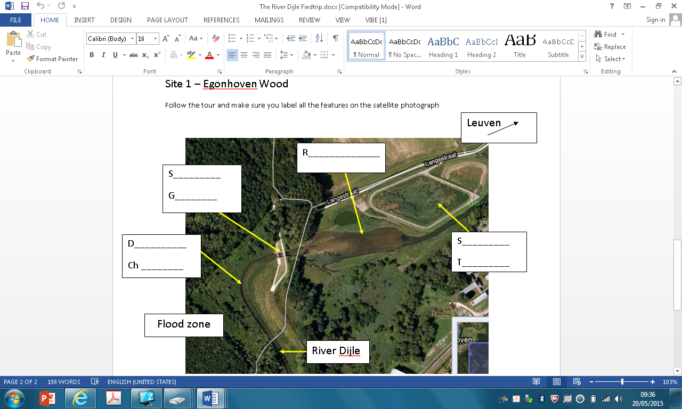

1. Using your data draw a graph that best presents it.
2. Draw sketch map of the fieldwork location and label its characteristics.
3. Mark on your map the location of meanders and draw a sketch diagram of one to explain how they form.
4. Present your work in the best structure that works for you.

Grading Criteria

|  |  |  |  |  |  |
| --- | --- | --- | --- | --- | --- |
| **Annotated Photo** | At least 2 problems identified  (2) | Fully explained  (2) |  |  | **4 marks** |
| **Annotated Satellite Photo** | Fully labelled  (4) | Annotation that explain each feature  (4) | Clear links to problems  (2) |  | **10 marks** |
| **Graph** | Accurately drawn  (3) | Titles and axis titles  (1) | Appropriate technique  (1) |  | **5 marks** |
| **Sketch map** | Well drawn  (4) | Clear title, frame, north arrow, scale  (2) | Well annotated with different characteristics  (3) | Accurate location of Meander  (1) | **10 marks** |
| **Meander sketch** | Accurately drawn  (2) | Clear labels of features  (2) | Processes are clearly explained  (2) |  | **6 marks** |
| **Total** | | | | | **40 Marks** |

Sketch map of Fieldwork Location with characteristics

Diagram of a meander

Graph of Data