Natural or Man-Made Rivers
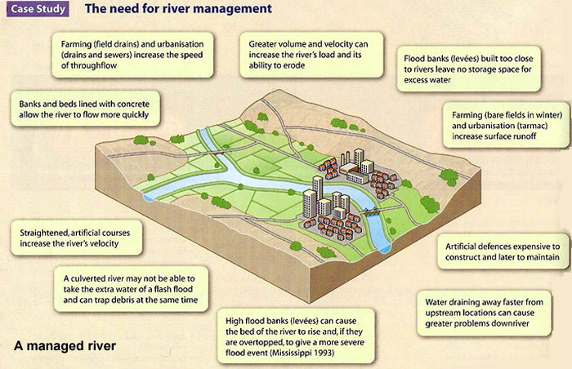

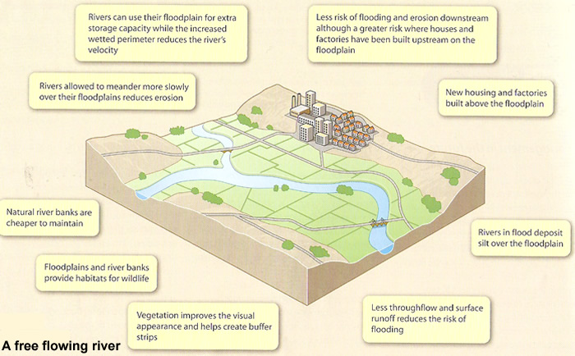

Activity: Look at the two river images above and describe the differences
________________________________________________________________________________________________________________________________________________________________________________________________________

ACTIVITY: Read the following statements and place the correct number in the boxes provided.
- Straightened channels speed up the river flow
- New houses and industry built above the floodplain
- Beds and bank lined with concrete to prevent erosion
- Rivers are allowed to meander more slowly causing less erosion
- Artificial defences are expensive to construct
- Natural river banks and floodplains allow more space for habitats
- High flood banks or levees hold back more water. If the river does flood the impacts will be greater
- River flood more often and deposit silt on the floodplain

ACTIVITY: Complete the table with ideas that explain why people manage rivers.

Environmental Reasons  Relates to the physical environment | Social Reasons  Relates to the impacts on people and their wellbeing | Economic Reasons  Relates to the impact on people, jobs and industry

ACTIVITY: Discuss which of these factors are more important and why

ACTIVITY: Watch the video and complete the sentences
https://www.youtube.com/watch?v=tj7Y-81tq1w

- Hard engineering is large scale c___________________, often e________________and tries to prevent flooding

- Example _____________________

- Soft Engineering is a more n ______________way to reduce the impact of flooding with less i_______________ and more environmentally friendly methods

- Example ____________________
ACTIVITY: Write down what you think are the differences and advantages of hard and soft engineering

