Homework
Annotated map of China

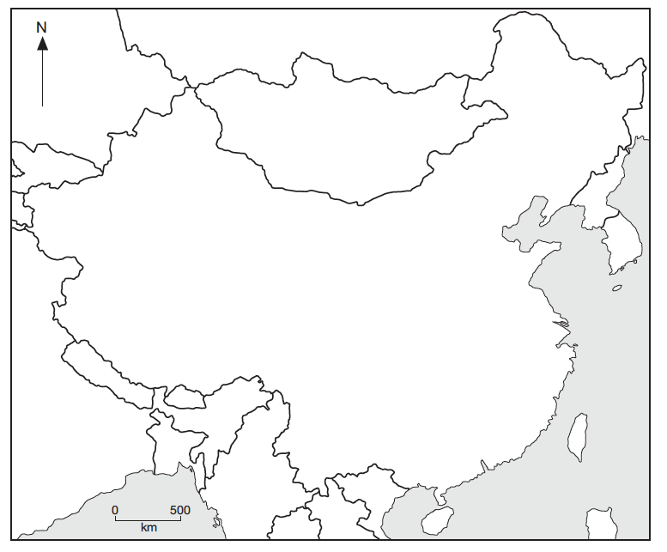

Aim: Your aim is to produce your own original annotated map of China.

Resources:
- Blank map of China ( copy on VLE)
Like the one above I suggest you print you map out in A4 & then place on an A3 sheet to allow detailed annotation and space for a key.
- Information cards used in class ( copy on the VLE).
- Atlas or Google Earth.

You should use the information on the cards given out in class, as well as an atlas to produce your map. Your map should include the main physical & human features ( rivers, deserts, cities…). All good maps should include the following characteristics: a title, frame key, north arrow and scale. Effective use of colour is also important. Your work will marked using the following criteria. 5 marks will be awarded for originality/extension. To gain these marks you have to do all the above plus something extra ( choropleth map to cover China’s temperature or precipitation or population density….)
26-30 – A* Assessment Criteria
20-25 - A
16-19 - B
12-15 – C
9-11 – D
< 8 - E
Criteria | Marks
Basic map characteristics | 5
Use of effective key | 5
Clear physical features | 5
Clear human features | 5
Detailed annotations | 5
Extension/originality | 5
Total | 30

