A Mushroom rock and perhaps a Butte!
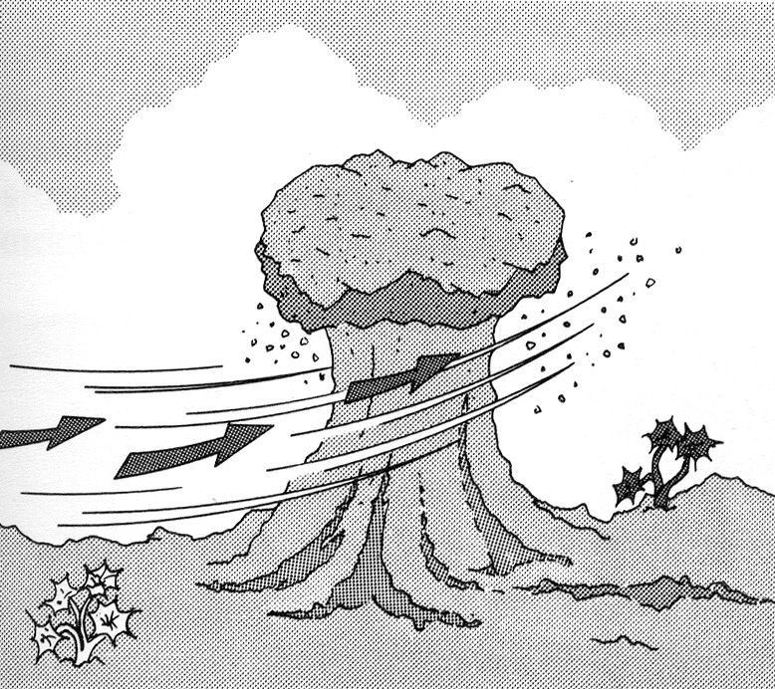
Homework : To explain how two desert landforms have been created.
Task:
- You must draw two desert landforms.
- You must explain how the landforms were created.
- You should incorporate geographical vocabulary.
- You must refer to key geographical processes (erosion & weathering) in your explanation.
- You may annotate your drawings to explain how they formed or just explain in a paragraph under the drawing.
Mark Scheme
Grades | Guidance
A* | A perfect explanation for both landforms using geographical vocabulary and covering all key processes ( different types of erosion & weathering) are required at this level. Your drawings should be neat and well presented.
A | An explanation of both landforms using good geographical vocab and also covering key processes in detail at this level, as well as a neat well presented diagram.
B | The student will produce well presented labeled diagrams. The student will make a good attempt to use key vocab and explain the processes, but some detail may be missing or the explanations may not always be totally clear.
C | The student will produce complete, neat diagrams and all landforms will be labeled. The student should make some attempt to explain the formation and refer to some processes
D | The student will produce a complete, neat diagram and all landforms will be labeled or the student will refer to some processes
E | The student will produce a basic diagram and attempt to add some labels or try to refer to some processes.

Below is a writing frame for a mushroom rock, which you may choose as one of your landforms.
A long time ago in a hot and sandy desert there was a mushroom rock. This rock looked...

The rock was formed by onion-skin weathering. This is when during the day...

At night the rock...

As the rock expands (gets bigger) and contracts (gets smaller)....
The wind also e_____ the rock …………………

